***India!***

Your student is being invited on the 2016 tour to

**How does my student benefit from this trip?**

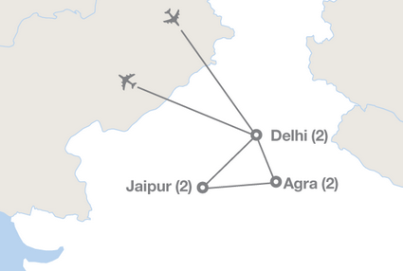Our world is becoming smaller and increasingly globalized with each and every day. Therefore, it has also become increasingly beneficial for today’s generation of students to experience the world on an international scale more than ever before. What better way to help your student get a step ahead

Brings their classroom to life

Engages their learning

Inspires them to be more

A more enhanced global view

A better understanding of the world

Builds self confidence

Develop 21st Century Skills

Stand out on amongst peers

of their peers than sending them on an international educational tour with a school and teacher they trust.

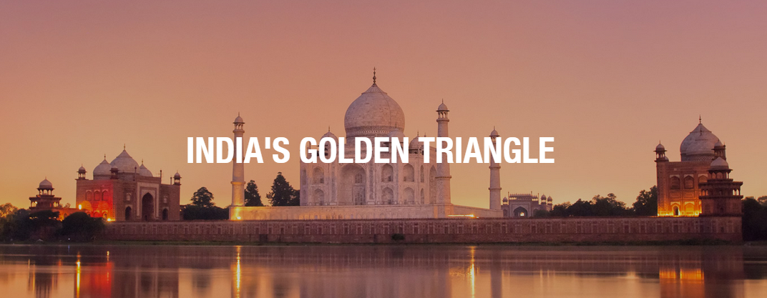 ­­

**Interested?**

**Informational meeting on** 9/15 at Room 102 at 5:00-6:00 pm

**RSVP to** Ms Bano at banonajma@hotmail.com by 9/9/2015

**Traveling with**

**Ms. Bano and**

**EF Educational Tours**

Leader in International Education

Low Price Guarantee

Global Travel Protection

50 years of experience

Offices in 107 countries

Fully Accredited

Payment plans